Design and Development of an RC Car using Arduino Uno, Motor Driver, Motors, and Li-ion Battery

Abstract
The advancement of low-cost embedded system has significantly influenced robotics and automation research. This paper presents the design, implementation, and evaluation of a radio-controlled(RC) car powered by Arduino Uno, motor driver circuitry, four DC motors, and a rechargeable lithium-ion battery. The system integrates wireless control with efficient power management to achieve smooth mobility and reliable operation. The developed RC car demonstrates real-world applications in robotics education, autonomous navigation experiments, and low-cost transportation prototypes. Beyond it’s technical contribution, the project also emphasizes the importance of hands-on experimentation, problem-solving, and the potential of open-source platforms in shaping the future of robotics.

Keywords
Arduino Uno, Motor Driver, DC Motor, Li-ion Battery, RC Car, Embedded Systems.

- Introduction
The increasing use of embedded system in robotic applications has encouraged the development of cost-efficient and customizable robotic platforms. RC Cars among the most common and practical projects for testing control algorithms, wireless communication modules, and energy management systems. Such projects provide students and researchers with an entry point into advanced robotics concepts like mechatronics integration, control theory, and autonomous vehicle navigation. Traditional RC Cars are often pre-assembled and limited in terms of programmability. In contrast, Arduino-based RC cars allow full customization, enabling researchers to implements features such as speed control, obstacle detection, line-following, and autonomous navigation. This flexibility makes them ideal platforms for both academic and hobbyist purposes.
This research focuses on developing a four-wheel RC car using Arduino-uno, an L298N motor driver module, four DC motors, and a Li-ion battery pack. The system is controlled wirelessly via a Bluetooth interface(HC-05), providing a balance between low cost, efficiency, and expandability.

- Literature Review
Several studies have investigated Arduino-controlled robotic platforms and highlighted their educational and industrial significance. The review below summarizes prior work in relevant fields:
- Embedded systems in Robotics- Previous work highlights the role of Arduino in rapid prototyping, providing affordable solutions to robotics and research. Arduino’s simplicity makes it a widely adopted tool in universities and schools.
- Motor Driver Circuits- Research shows that L298N motor drivers are efficient for driving low-voltage DC motors in small-scale robotics project. They are cost-effective, widely available, and capable of controlling multiple motors with direction and speed functionality
- Energy storage in Robotics- Li-ion batteries are preferred due to their high energy density, lightweight design, and rechargeability. They outperform traditional batteries in both runtime and durability.
- RC Car Application- Studies demonstrates RC cars as testbeds for machine learning, IoT integration, and intelligent transportation systems. For example, researchers have tested autonomous lane-following algorithm on scaled-down RC car before implementing them in full sized vehicles.
- Materials and Methodology
  - components Used
. Arduino Uno- Serves as the central microcontroller responsible for
processing commands and executing control algorithms.
. L298N Motor Driver – Manages motor speed and direction by receiving
signals from the Arduino Uno.
. 4 DC Motors(300 rpm) – Provide the propulsion force required for car
movement and turning.
. Li-ion Battery Pack – Acts as the primary power supply, ensuring
extended runtime.
. Chassis with Wheels – Provides the structural framework for mounting
motors, electronics, and power supply.
. Bluetooth Module(HC-05) – Allows wireless control through a
smartphone app.
. Jumper Wires & Breadboard – Facilitate circuit connections and
modular testing.

  - Block Diagram
Smartphone(Bluetooth App) -> HC-05 Module -> Arduino Uno -> L298N Motor Driver -> DC Motors -> Car Movement

  - Methodology Steps
- Hardware Assembly – Motors are mounted onto the chassis, connected to the L298N driver, and interfaced with Arduino Uno. Care was taken to minimize wiring errors and ensure proper load balancing of the chassis.
- Programming – Arduino IDE was used to develop code for forward, backward, left and right motion. PWM(Pulse Width Modulation) signals were implemented to achieve speed control.
- Wireless Control – The HC-05 module was paired with a smartphone. A mobile app sent directional commands which Arduino decoded into motor actions.
- Testing – Experiments included straight-line travel, obstacle avoidance trials, battery discharge monitoring, and performance under varied loads.

- Results
The RC car prototype was successfully developed and tested. The experimental evaluation showed the following result:
. Speed: Achieved between 0.8 – 1.2 m/s depending on motor power and
battery charge.
. Battery Life: 35-45 minutes on a full charge, depending on terrain and
driving patterns.
. Control range: 8-12 meters using the HC-05 Bluetooth module.
. Performance: Smooth directional control was achieved, including forward,
reverse, and sharp turns.
. Expandability: The modular design makes it possible to integrate ultrasonic
sensors, cameras, or IoT modules for advanced applications.

- Discussion
The RC car successfully demonstrates the feasibility of using low-cost electronic components for building customizable robotic platforms. Arduino Uno provided flexibility and ease of use, while the L298N driver effectively managed four DC motors. The Li-ion battery packed ensured sufficient energy storage for prolonged operations, making the system practical for real-life experimentation. However, the project encountered challenges such as heating of the motor driver under extended usage and the limited range of Bluetooth communication. While Bluetooth is sufficient small scale projects, larger experimental setups may require Wi-Fi communication for extended range.

- Conclusion
The research successfully demonstrated the design and construction of an RC car using Arduino Uno, L298N motor driver, four DC motors, and a Li-ion battery. Wireless control was achieved through the HC-05 Bluetooth module, enabling flexible and efficient operation. The project not only achieved reliable movement but also established a foundation for future enhancements such as automation, AI integration, and IoT- based monitoring. Thus, the RC car serves as a cost-effective educational and research platform in the field of embedded systems and robotics.

Circuit Diagram

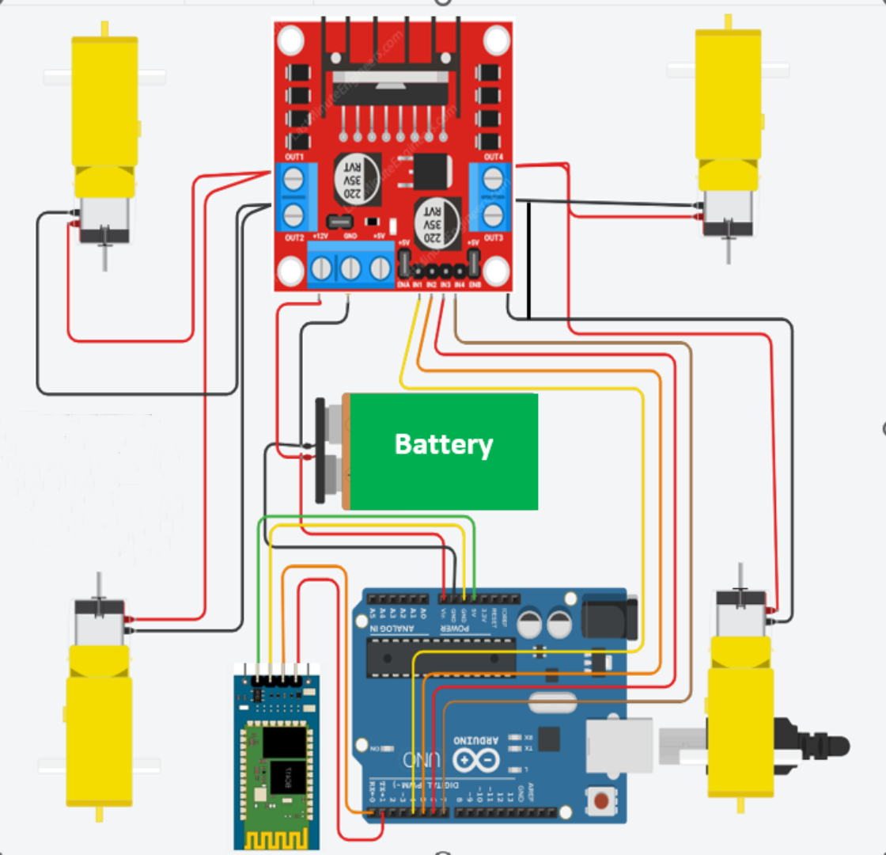
Arduino IDE Code
char data; // Variable to store received data

void setup() {
Serial.begin(9600); // Start serial communication at 9600 baud rate

// Set motor control pins as output
pinMode(7, OUTPUT);
pinMode(6, OUTPUT);
pinMode(5, OUTPUT);
pinMode(4, OUTPUT);

}

void loop() {
if (Serial.available() > 0) {
data = Serial.read(); // Read received data

// Control motor movement based on received data
switch (data) {
case 'F': // Move Forward
digitalWrite(7, HIGH);
digitalWrite(6, LOW);
digitalWrite(5, HIGH);
digitalWrite(4, LOW);
break;
case 'B': // Move Backward
digitalWrite(7, LOW);
digitalWrite(6, HIGH);
digitalWrite(5, LOW);
digitalWrite(4, HIGH);
break;
case 'R': // Turn Left
digitalWrite(7, LOW);
digitalWrite(6, HIGH);
digitalWrite(5, HIGH);
digitalWrite(4, LOW);
break;
case 'L': // Turn Right
digitalWrite(7, HIGH);
digitalWrite(6, LOW);
digitalWrite(5, LOW);
digitalWrite(4, HIGH);
break;
case 'S': // Stop
digitalWrite(7, LOW);
digitalWrite(6, LOW);
digitalWrite(5, LOW);
digitalWrite(4, LOW);
break;
}
}
}

